**Assignment 3: Representing Relationships**

Student Name: Xiaoyi Yu

Student ID: 1663782

1. 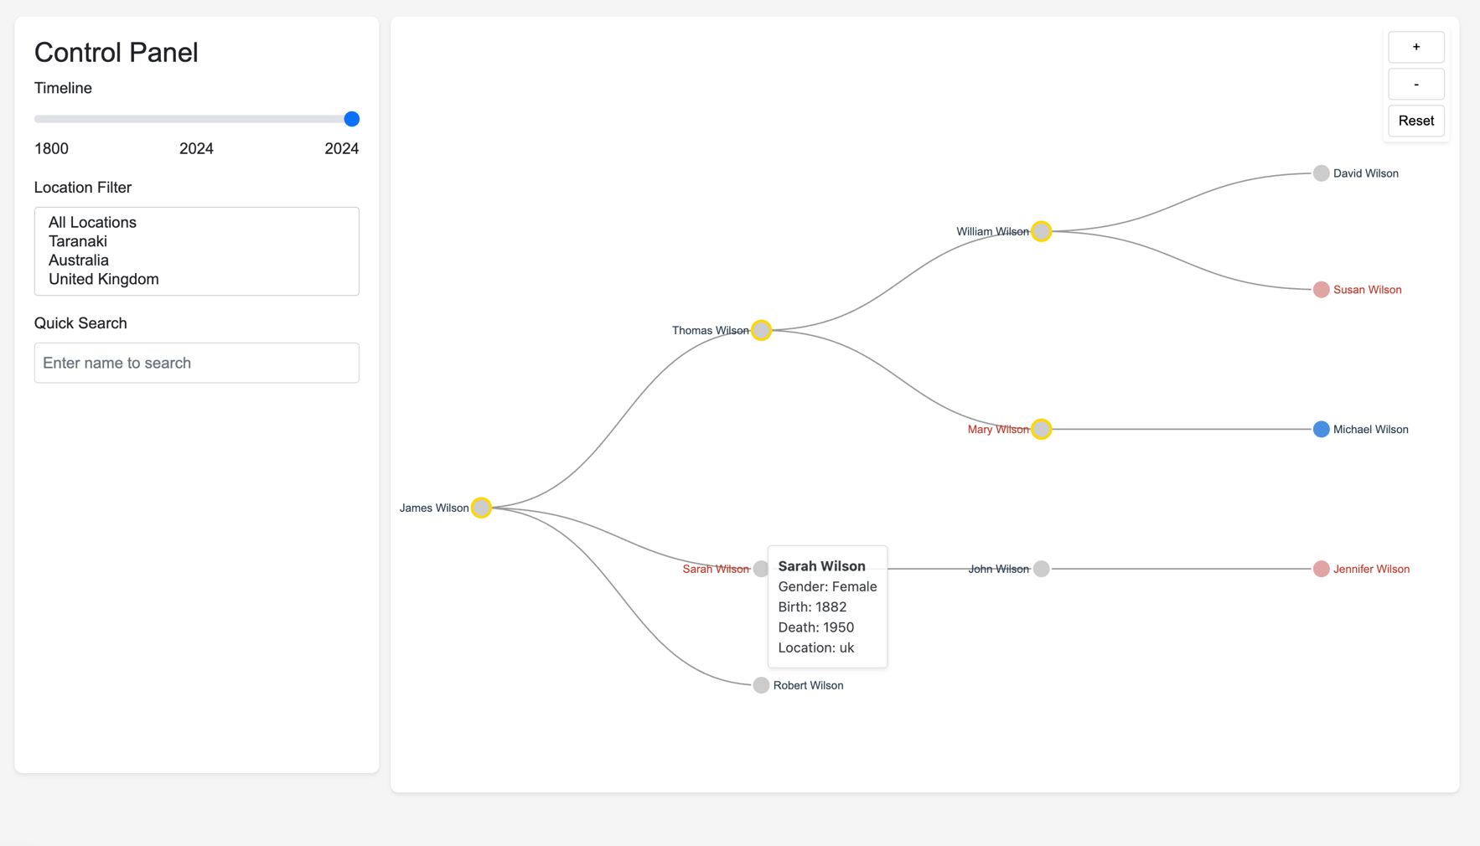**System Display**
2. **System Features**
3. Users can zoom in/out using the +/- buttons or mouse wheel
4. Users can identify gender through color coding:

• Blue nodes represent male family members

• Pink nodes represent female family members

• Gray nodes indicate deceased members

• Green nodes indicate members not yet born (relative to selected year)

1. Users can drag the timeline slider to observe family members' survival status

• Active range: 1800-2024

• Members who died before the selected year appear in gray

1. Users can filter family members by location using the dropdown menu:

• All Locations

• Taranaki

• Australia

• United Kingdom

1. Users can search for specific family members using the search box

• Real-time filtering as you type

• Highlights matching members

1. Users can click on any family member to:

• Highlight direct relationships

• Show parents and children

• Identify siblings and cousins

1. Users can hover over nodes to view detailed information:

• Full name

• Birth year

• Death year (if applicable)

• Current location

1. Users can pan the visualization by clicking and dragging

• Reset button returns to default view

• zoom level during panning

1. **Example Demonstrations**
2. "Show me all of the first cousins of X"

Example using Michael Wilson:

Click on Michael Wilson's node

System highlights:

• His parent (Mary Wilson)

• His cousins:

• David Wilson

• Susan Wilson

• Jennifer Wilson

图示

AI 生成的内容可能不正确。

1. "Which members of the family were living during the 1914-18 war?"

• Steps:

• Move timeline slider to 1914

• Observe colored (living) nodes:

• Thomas Wilson (1880-1940)

• Sarah Wilson (1882-1950)

• Robert Wilson (1885-1960)

• Elizabeth Brown (1905-1980)

• William Wilson (1910-1970)

• Mary Wilson (1912-1990)

图表

AI 生成的内容可能不正确。• John Wilson (1915-2000)

1. "Which members of the family ever lived in Taranaki?"

• Steps:

• Select "Taranaki" from location filter

• System highlights:

• James Wilson (1850-1910)

• Robert Wilson (1885-1960)

• John Wilson (1915-2000)

• Michael Wilson (1945-)

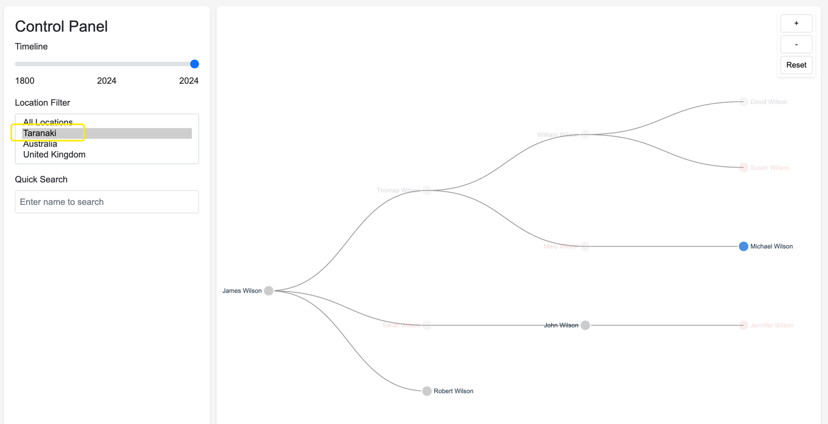

1. "Does X have any cousins in Australia?"

Example using Michael Wilson:

• Click on Michael Wilson's node

• Select "Australia" from location filter

• System shows:

His cousin David Wilson lives in Australia

Relationship path:

Michael Wilson → Mary Wilson (mother) → Thomas Wilson (grandfather) → William Wilson (uncle) → David Wilson (cousin)

